**ABSTRACT:**

**Environmental monitoring describes the processes and activities that need to take place to characterize and monitor the quality of the environment.**

**Environmental monitoring is used in the preparation of environmental impact assessments, as well as in many circumstances in which human activities carry a risk of harmful effects on the natural environment.**

**In all cases, the results of monitoring will be reviewed, analyzed statistically, and published.**

**The design of a monitoring program must therefore have regard to the final use of the data before monitoring starts.**

**Environmental monitoring includes monitoring of air quality, soils quality, water management etc...**

**FLOWCHAT FOR AIR QUALITY:**

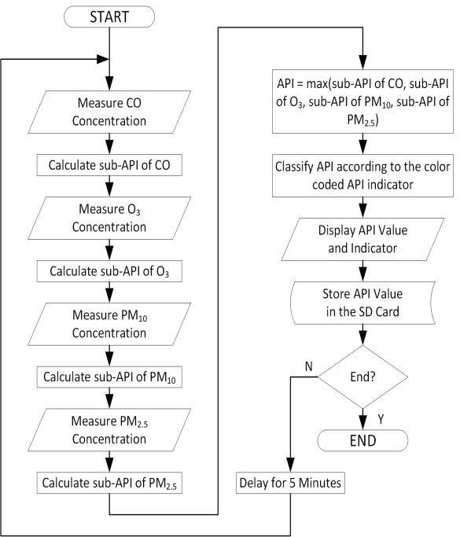

**The use of multi-parameter air quality monitoring systems makes it possible to do a detailed level analysis of major pollutants and their sources.**

**These monitoring systems are important components in many smart city projects for monitoring air quality and for controlling the main pollutant concentrations in urban areas.**

**WATER MANAGEMENT**

**During the past decade, water needs have increased unpredictably in India. Increasing demand of water supply has become a major challenge for the world. Wasteful usage of water, climatic changes and Urbanization has further depleted the resource. Conservation and management of the resource must be given utmost importance. In this paper, we present an IoT design for water monitoring and control approach which supports internet based data collection on real time bases. The system addresses new challenges in the water sector -flow rate measuring and the need for a study of the supply of water inorder to curb water wastage and encourage its conservation. We also measure the quality of water distributed to every household by deploying pH and conductivity sensors. The traditional water metering systems require periodic human intervention for maintenance making it inconvenient and often least effective.For shortcoming of the existing models for a ubiquitous usage of wireless systems for smart quality monitoring and communicate data wirelessly.**

**FLOWCHART FOR SMART WATER MANAGEMENT:**

